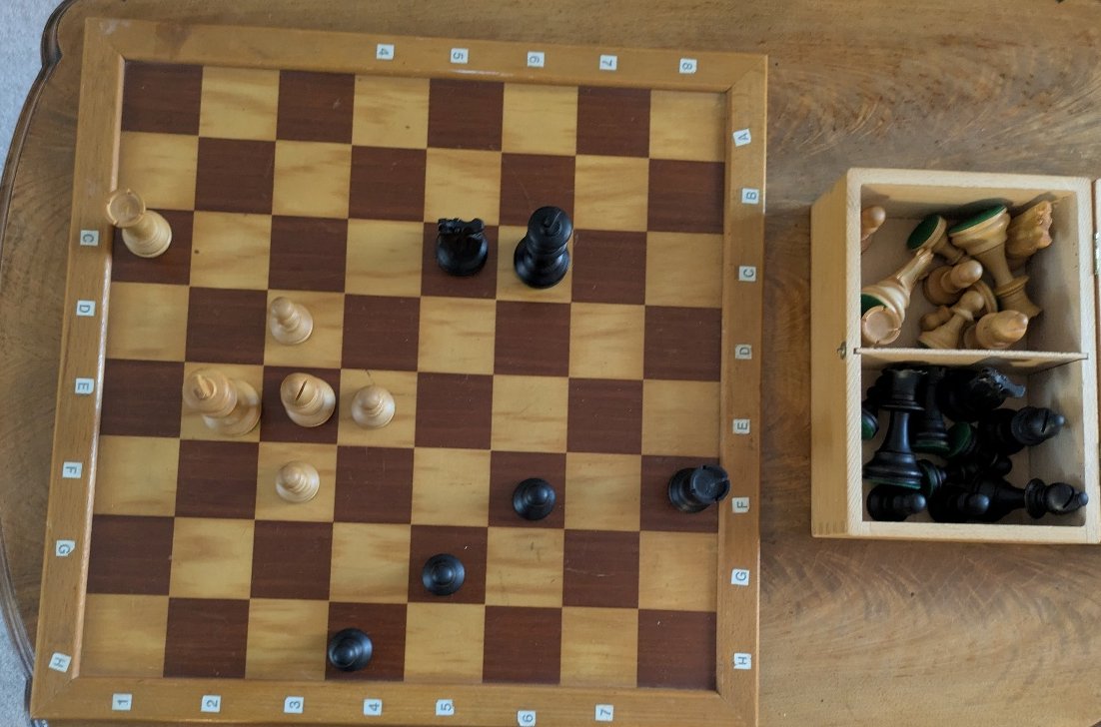
You can quite easily see the pieces of the board and what they look like and can more easily interact with them making it easier to learn and understand how each piece moves.
Although the pieces look nice and are easy to work with if you lose some pieces, it will be a pain as you can no longer use the board to its full effectiveness.
A real chess board is great as you can clearly see the pieces up close and its 3D so you can see it from lots of angles and make it easily see moves with physical pieces. The main problem with a physical board though is that it is quite small so can only really be used for a small class else most people will not be able to see the small board and you would need to remember all the pieces for the board states.

